GUIDE TO THE CHEMUK 2020 EXHIBITOR MARKETING TOOLKIT

Personalised Registration Link & Promo Code

Use this link or promo code, whenever you are inviting anyone to come and see you at the show. Anyone who registers using this link or code will be hi-lighted to the CHEMUK team and we will be able to inform you prior to the event, giving you the opportunity to contact them via the CHEMUK Networking Portal ‘CHEMUK Connect’.

Personal Drop Box
Here we will add any files created for you, things you will find in here (if you have ordered them)

- Social Media Card - Post as and when you like on LinkedIn & Twitter, please remember to either tag in the show @CHEMUKEXPO or use #CHEMUK

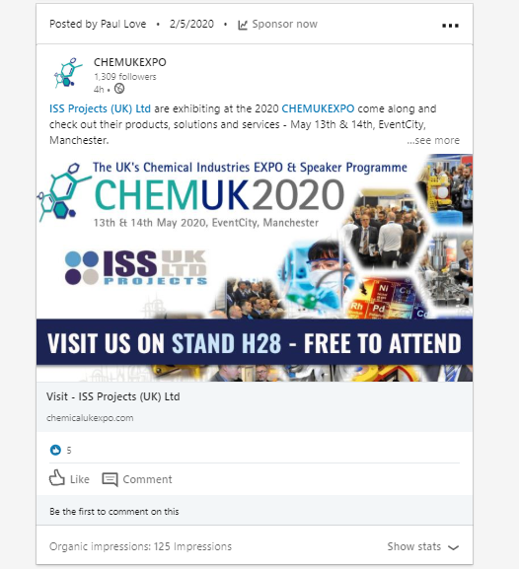

- Email Signature - Simply add to yours and colleagues email signature and link to your profile page on our website.

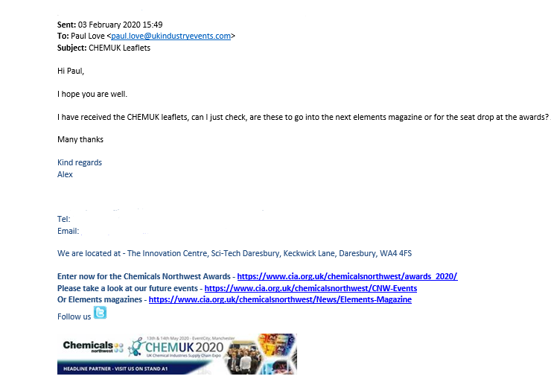

- Digital Printed Flyer – Ideas for Distribution:
- Direct mailing with covering letter to Prospects/Clients inviting them to the show ask them to register using our promo code in the letter
- Send out with Orders/Invoices or use Online version and attach
- Distribute via sales team if visiting customers/prospects or attending other exhibitions

- HTML Template - All the required files are in your drop box and ready for you to slot into your mailing software. Find under ‘HTML Template’ folder and click on ‘email’.

To attain best results, we recommend sending from 6 weeks out (April 1st) every couple of weeks leading up to the event. These are all coded with your personalised registration code so you will receive the company & job title of each attendee who registers through your email prior to the event.

- Website Banner - Please find in your dropbox. If you have sent your dimensions this will have been created for you. Please upload to your website and we recommend linking to your exhibitor profile.

General Drop Box

- CHEMUK Logo’s & 2019 Show Images
- Venue Logo and Images
- 2020 Floor Plan
- Show Copy
- Neutral Testimonials
- Diary Information

Client Invitation Service
We will do our best to contact your key target clients and invite them to the event.

If you haven’t sent in your list, then please do so before the end of February 2020; company name, website and example job titles.

